|  |  |  |
| --- | --- | --- |
| **Literacy and English**  Letter formation - Practise making patterns and the letters you know in sand, rice, shaving foam, paper or use a stick to practise in the mud. Can you write your first and last name? | **Numeracy and Mathematics**  Forward count - Count out loud as far as you can go.  Start at 3 and stop at 6  Start at 5 and stop at 9  Start at 8 and stop at 12  Start at 2 and stop at 7  Can you try any more? | **Health and Wellbeing**  Outdoor Learning - Set up an obstacle course in your house or outside and see how long it takes you to complete it. Can you do it quicker each time? |
| **Literacy and English**  Reading - Choose a favourite story. First, ask a grown-up to read it to you. Next, you re-tell the story in your own words. Draw a picture of your favourite part of the story and talk about why you liked that part.  Can you think of a different ending to the story? | **Numeracy and Mathematics**  Backward count – Count back from 5, 10, 15 or 20  Start at 5 count back to 2  Start at 7 count back to 3  Start at 12 count back to 8  Start at 10 count back to 4  Can you try any more? | **STEM**  Science - Make a boat out of this paper and see if it will float in your sink. Try and see if it could carry an object like a lid or a biscuit. Can it carry a heavier object? What happens when it is too heavy and why? |
| **Literacy and English**  Comprehension - Watch the Paddington film trailer - here is the link <https://www.youtube.com/watch?v=7bZFr2IA0Bo>  Then discuss the trailer with an adult.  What are the names of all the characters?  How did Paddington get his name?  Do you think Paddington is a friendly bear? Why?  Would you like to see the film and why? | **Numeracy and Mathematics**  Counting objects – find things around the house to count out loud. How many cushions? How many lights? How many cups? How many shoes? How many chairs? How many toys? | **Expressive Arts**  Design a new jacket for Paddington.  Where is Paddington Bear from, why does he have a blue coat and suitcase,  how many books are there and where's the statue? |
| **Literacy and English**  Rhyming Words –which words rhyme with -  **cat, net, tin, fan, cup, rot, bag, lick, tea, my**  Can you say this nursery rhyme?  Hey Diddle Diddle  The Cat and the fiddle  The cow jumped over the moon  The little dog laughed to see such fun  And the dish ran away with the spoon.  Which words rhyme? | **Numeracy and Mathematics**  1-49 Snakes & Ladders Half Solid Playground Markings1:1 Correspondence - Play a game of snakes and ladders using the board below. | **Social Studies**  People Who Help Us - Make a thank you card for your teacher who will be missing you while you are at home. Think about what they might like to see on the card. Can you write your first and last name on it? |
| **Literacy and English**  Talk about your favourite toy for 1 minute. What is its name? Why do you like it? Where did you get it from? Where do you keep it? What does it look like? | **Problem Solving**  Finish the patterns in the sheet below.  Can you make up some patterns of your own? | **Health and Wellbeing**  Go on a walk with a grown-up and on your return, draw a map of where you have been. |

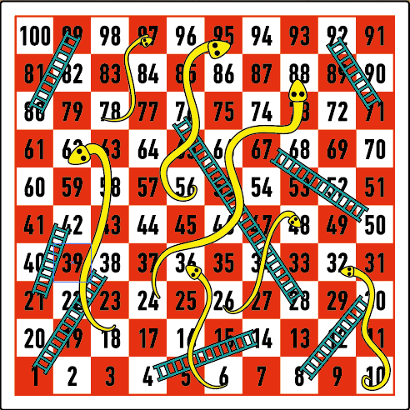

Finish the Pattern

